ANALYSIS OF INVESTMENT AVENUES

1. INTRODUCTION
Investment is the process of committing money or capital to an asset or venture with the expectation of earning income or profit in the future. In today’s dynamic financial environment, investment has become a necessity rather than a choice. Rising inflation, increasing living costs, and uncertain economic conditions make saving alone insufficient. Hence, individuals invest their savings to grow wealth, secure their future, and achieve long-term financial goals.
Investment avenues refer to the various options available to investors to park their funds. These avenues differ in terms of risk, return, liquidity, safety, and time horizon. Some investments offer high returns with high risk, while others provide safety with moderate or low returns. Therefore, choosing the right investment avenue is crucial for financial success.
This report aims to analyse major investment avenues such as equity shares, mutual funds, IPOs, fixed deposits, bonds, gold, and real estate, using real-time market trends. The study highlights their features, advantages, risks, and suitability for different types of investors.
2. OBJECTIVES OF THE STUDY
The main objectives of this report are:
To understand the concept of investment avenues
To analyse various popular investment options
To compare risk and return associated with each avenue
To study current market trends (real-time data-based analysis)
To identify suitable investment options for different investors
3. Overview of Major Investment Avenues
3.1 Equity Shares (Stock Market)
Equity shares represent ownership in a company. When an investor buys shares, they become part owners of the company and are entitled to dividends and capital appreciation.
Current Market Scenario
Indian stock markets have shown strong growth in recent years.
Indices like Nifty 50 and Sensex have reached record highs, reflecting positive investor sentiment.
US markets such as S&P 500 and NASDAQ continue to perform strongly, driven by technology and innovation.
ADVANTAGES
- High return potential
- Ownership rights
- Liquidity (easy buying and selling)
- Protection against inflation
DISADVANTAGES
- High market risk
- Price volatility
- Requires market knowledge
- Suitability
Equity shares are suitable for risk-taking investors and long-term investors aiming for wealth creation.
3.2 Mutual Funds
Mutual funds collect money from many investors and invest it in diversified portfolios of stocks, bonds, or other securities. They are managed by professional fund managers.
Types of Mutual Funds
- Equity Funds
- Debt Funds
- Hybrid Funds
- Index Funds
- Sectoral Funds
- Current Trends
- Mutual fund investments are growing rapidly in India.
SIPs (Systematic Investment Plans) have become popular among young investors.
Assets under management (AUM) of mutual funds are increasing steadily.
Advantages
- Diversification reduces risk
- Professional management
- Affordable through SIPs
- Suitable for small investors
Disadvantages
- Market-linked risks
- Management fees
- Returns not guaranteed
- Suitability
Mutual funds are ideal for moderate-risk investors and those who lack time or expertise to manage investments.
3.3 Initial Public Offerings (IPOs)
An Initial Public Offering (IPO) is when a private company offers its shares to the public for the first time. IPOs provide an opportunity to invest in a company at an early stage.
Recent IPO Trends
India has witnessed a surge in IPO activity.
Many companies from technology, finance, and manufacturing sectors have gone public.
IPO participation by retail investors has increased significantly.
Advantages
- Opportunity for early investment
- Potential listing gains
- Portfolio diversification
- Risks
- High price volatility
- Limited historical data
- Market sentiment impact
- Suitability
IPOs are suitable for investors with moderate to high risk appetite who can analyze company fundamentals.
3.4 Fixed Deposits (FDs)
Fixed Deposits are traditional investment options offered by banks and financial institutions, providing fixed interest over a specific period.
Features
- Fixed tenure
- Guaranteed returns
- Low risk
- Advantages
- Safety of capital
- Assured income
- Easy to understand
Disadvantages
- Low returns
- Inflation risk
- Taxable interest
- Suitability
FDs are suitable for risk-averse investors, senior citizens, and those seeking stable income.
3.5 Bonds and Debentures
Bonds are debt instruments where investors lend money to governments or companies in exchange for periodic interest.
Advantages
- Stable income
- Lower risk compared to equities
- Capital preservation
Disadvantages
- Lower returns
- Interest rate risk
- Suitability
Suitable for conservative investors and those seeking predictable returns.
3.6 Gold Investment
Gold has always been considered a safe-haven investment. Investors can invest in gold through physical gold, gold ETFs, and sovereign gold bonds.
Advantages
- Hedge against inflation
- Safe during economic uncertainty
- Portfolio diversification
Disadvantages
- No regular income
- Storage cost (physical gold)
- Suitability
- Gold is suitable for long-term investors and those seeking stability.
3.7 Real Estate
Real estate involves investment in land or buildings for rental income or capital appreciation.
Advantages
- Long-term value appreciation
- Rental income
- Tangible asset

Disadvantages
- High initial investment
- Low liquidity
- Maintenance cost
- Suitability
Real estate is suitable for high-capital investors with a long-term horizon.
4. COMPARATIVE ANALYSIS OF INVESTMENT AVENUES
Investment Avenue
- Risk
- Return
- Liquidity
- Safety
Equity Shares
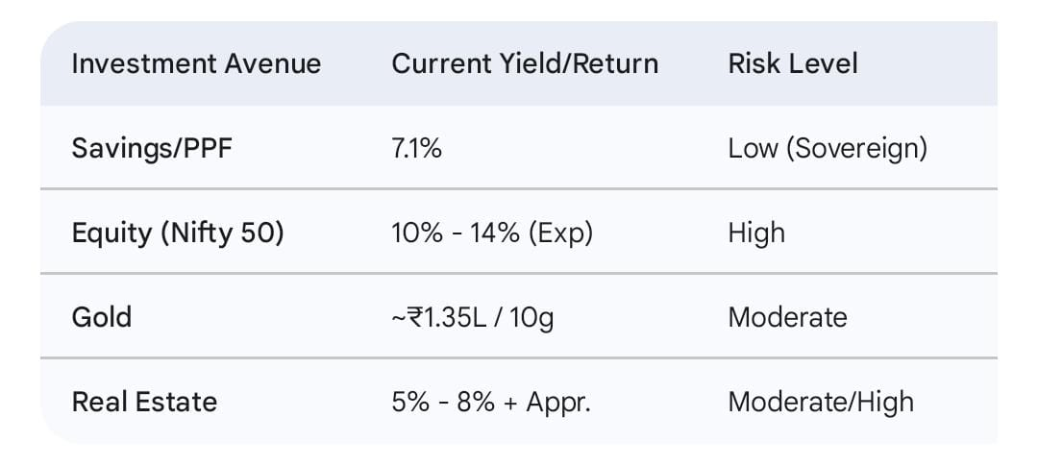
5. FINDINGS OF THE STUDY
- No single investment avenue is perfect.
- Equity and IPOs offer high returns but involve high risk.
- Mutual funds provide a balance between risk and return.
- Fixed deposits and bonds offer safety but low growth.
- Gold and real estate help in diversification.
6. CONCLUSION
Investment is an essential tool for financial growth and security. With multiple investment avenues available, investors must carefully evaluate their financial goals, risk tolerance, time horizon, and market conditions before making decisions. Equity shares, mutual funds, and IPOs provide higher growth opportunities, while fixed deposits, bonds, and gold ensure stability and safety.
A balanced and diversified portfolio is the key to successful investing. By allocating funds across different investment avenues, investors can minimize risk and maximize returns. Thus, proper analysis and informed decision-making are crucial for achieving long-term financial success.

